**IMPORTING DATA:**

**DATA CLEANING:**

**----Data cleaning**

**----Removing the nulls**

DELETE FROM dbo.obesity_data

WHERE Age IS NULL

OR gender IS NULL

OR Veg_intake IS NULL

OR No_of_meals_intake IS NULL

OR Water_intake IS NULL

or Physcial_Activity is null

or Height is null

or weight is null ---(o rows affected)

**---Removing decimals from columns:**

update dbo.Obesity_data SET Age = Round(Age,0) ----(2111 rows affected)

update dbo.Obesity_data SET Veg_intake = Round(Veg_intake,0) ----(2111 rows affected)

update dbo.Obesity_data SET No_of_meals_intake = Round(No_of_meals_intake,0) ----(2111 rows affected)

update dbo.Obesity_data SET Water_intake = round(Water_intake,0) ----(2111 rows affected)

update dbo.Obesity_data SET Physcial_Activity = round (Physcial_Activity,0) ----(2111 rows affected)

update dbo.Obesity_data SET Tech_using_time= round (Tech_using_time, 0) ----(2111 rows affected)

ALTER TABLE dbo.obesity_data ALTER COLUMN Tech_using_time decimal(9,0)

ALTER TABLE dbo.obesity_data ALTER column Height decimal(9,2)

ALTER TABLE dbo.obesity_data ALTER COLUMN Weight decimal (9,0)

Select Age,Height,Weight,Veg_intake,No_of_meals_intake,Water_intake, Physcial_Activity,Tech_using_time from dbo.Obesity_data

**-----BINARIZATION CODE:**

----Family history with over weight

Select count (family_history_with_overweight) as freq_no from dbo.Obesity_data where family_history_with_overweight = 'no'---385

Select count (family_history_with_overweight) as freq_no from dbo.Obesity_data where family_history_with_overweight = 'yes'--1726

UPDATE dbo.Obesity_data SET family_history_with_overweight = REPLACE(family_history_with_overweight, 'no','0')

Select count (family_history_with_overweight) as freq_no from dbo.Obesity_data where family_history_with_overweight = '0' ---385

UPDATE dbo.Obesity_data SET family_history_with_overweight = REPLACE(family_history_with_overweight, 'yes','1')

Select count (family_history_with_overweight) as freq_no from dbo.Obesity_data where family_history_with_overweight = '1'---1726

----high cal intake:

Select count (High_Cal_intake) as freq_no from dbo.Obesity_data where High_Cal_intake = 'no'---245

Select count (High_Cal_intake) as freq_no from dbo.Obesity_data where High_Cal_intake = 'yes'--1866

UPDATE dbo.Obesity_data SET High_Cal_intake = REPLACE(High_Cal_intake, 'no','0')

Select count (High_Cal_intake) as freq_no from dbo.Obesity_data where High_Cal_intake = '0' ---245

UPDATE dbo.Obesity_data SET High_Cal_intake = REPLACE(High_Cal_intake, 'yes','1')

Select count (High_Cal_intake) as freq_no from dbo.Obesity_data where High_Cal_intake = '1'----1866

-----Consu_food_intake_betw_Meals

Select count (Consu_food_intake_betw_Meals) as freq_no from dbo.Obesity_data where Consu_food_intake_betw_Meals = 'no'---51

Select count (Consu_food_intake_betw_Meals) as freq_no from dbo.Obesity_data where Consu_food_intake_betw_Meals = 'sometimes'--1765

Select count (Consu_food_intake_betw_Meals) as freq_no from dbo.Obesity_data where Consu_food_intake_betw_Meals = 'Always'---53

Select count (Consu_food_intake_betw_Meals) as freq_no from dbo.Obesity_data where Consu_food_intake_betw_Meals = 'Frequently'---242

UPDATE dbo.Obesity_data SET Consu_food_intake_betw_Meals = REPLACE(Consu_food_intake_betw_Meals, 'no','0')

Select count (Consu_food_intake_betw_Meals) as freq_no from dbo.Obesity_data where Consu_food_intake_betw_Meals = '0' ---51

UPDATE dbo.Obesity_data SET Consu_food_intake_betw_Meals = REPLACE(Consu_food_intake_betw_Meals, 'Sometimes','1')

UPDATE dbo.Obesity_data SET Consu_food_intake_betw_Meals = REPLACE(Consu_food_intake_betw_Meals, 'Always','1')

UPDATE dbo.Obesity_data SET Consu_food_intake_betw_Meals = REPLACE(Consu_food_intake_betw_Meals, 'Frequently','1')

Select count (Consu_food_intake_betw_Meals) as freq_no from dbo.Obesity_data where Consu_food_intake_betw_Meals = '1'---2060

-----Smoke

Select count (SMOKE) as freq_no from dbo.Obesity_data where SMOKE = 'no'---2067

Select count (SMOKE) as freq_no from dbo.Obesity_data where SMOKE = 'yes'--44

UPDATE dbo.Obesity_data SET SMOKE = REPLACE(SMOKE, 'no','0')

Select count (SMOKE) as freq_no from dbo.Obesity_data where SMOKE = '0' ---2067

UPDATE dbo.Obesity_data SET SMOKE = REPLACE(SMOKE, 'yes','1')

Select count (SMOKE) as freq_no from dbo.Obesity_data where SMOKE = '1'----44

-----cal_intake

Select count (Cal_intake_Monitoring) as freq_no from dbo.Obesity_data where Cal_intake_Monitoring = 'no'

Select count (Cal_intake_Monitoring) as freq_no from dbo.Obesity_data where Cal_intake_Monitoring = 'yes'

Select count (Cal_intake_Monitoring) as freq_no from dbo.Obesity_data where Cal_intake_Monitoring= 'sometimes'--1401

Select count (Cal_intake_Monitoring) as freq_no from dbo.Obesity_data where Cal_intake_Monitoring= 'Always'---1

Select count (Cal_intake_Monitoring) as freq_no from dbo.Obesity_data where Cal_intake_Monitoring = 'Frequently'----70

UPDATE dbo.Obesity_data SET Cal_intake_Monitoring = REPLACE(Cal_intake_Monitoring, 'no','0')

Select count (Cal_intake_Monitoring) as freq_no from dbo.Obesity_data where Cal_intake_Monitoring = '0'

UPDATE dbo.Obesity_data SET Cal_intake_Monitoring= REPLACE(Cal_intake_Monitoring, 'yes','1')

UPDATE dbo.Obesity_data SET Cal_intake_Monitoring = REPLACE(Cal_intake_Monitoring, 'Sometimes','1')

UPDATE dbo.Obesity_data SET Cal_intake_Monitoring = REPLACE(Cal_intake_Monitoring, 'Always','1')

UPDATE dbo.Obesity_data SET Cal_intake_Monitoring = REPLACE(Cal_intake_Monitoring, 'Frequently','1')

Select count (Cal_intake_Monitoring) as freq_no from dbo.Obesity_data where Cal_intake_Monitoring = '1'---1472

----Alcohol

Select count (Alcohol_intake) as freq_no from dbo.Obesity_data where Alcohol_intake = 'no'---639

Select count (Alcohol_intake) as freq_no from dbo.Obesity_data where Alcohol_intake = 'sometimes'--1401

Select count (Alcohol_intake) as freq_no from dbo.Obesity_data where Alcohol_intake = 'Always'---1

Select count (Alcohol_intake) as freq_no from dbo.Obesity_data where Alcohol_intake = 'Frequently'---70

UPDATE dbo.Obesity_data SET Alcohol_intake = REPLACE(Alcohol_intake, 'no','0')

Select count (Alcohol_intake) as freq_no from dbo.Obesity_data where Alcohol_intake = '0' ---639

UPDATE dbo.Obesity_data SET Alcohol_intake = REPLACE(Alcohol_intake, 'Sometimes','1')

UPDATE dbo.Obesity_data SET Alcohol_intake = REPLACE(Alcohol_intake, 'Always','1')

UPDATE dbo.Obesity_data SET Alcohol_intake = REPLACE(Alcohol_intake, 'Frequently','1')

Select count (Alcohol_intake) as freq_no from dbo.Obesity_data where Alcohol_intake = '1'---1472

-----water intake

Select count (Water_intake) as freq_no from dbo.Obesity_data where Water_intake = '1'---485

Select count (Water_intake) as freq_no from dbo.Obesity_data where Water_intake = '2'--1110

Select count (Water_intake) as freq_no from dbo.Obesity_data where Water_intake = '3'---516

UPDATE dbo.Obesity_data SET Water_intake = REPLACE(Water_intake, '1','0')

Select count (Water_intake) as freq_no from dbo.Obesity_data where Water_intake = '0' ---485

UPDATE dbo.Obesity_data SET Water_intake = REPLACE(Water_intake, '2','1')

UPDATE dbo.Obesity_data SET Water_intake = REPLACE(Water_intake, '3','1')

Select count (Water_intake) as freq_no from dbo.Obesity_data where Water_intake = '1'---1626

---Physical activity:

Select count (Physcial_Activity) as freq_no from dbo.Obesity_data where Physcial_Activity = '1'---776

Select count (Physcial_Activity) as freq_no from dbo.Obesity_data where Physcial_Activity = '2'--496

Select count (Physcial_Activity) as freq_no from dbo.Obesity_data where Physcial_Activity = '3'---119

UPDATE dbo.Obesity_data SET Physcial_Activity = REPLACE(Physcial_Activity, '1','0')

Select count (Physcial_Activity) as freq_no from dbo.Obesity_data where Physcial_Activity = '0' ---1496

UPDATE dbo.Obesity_data SET Physcial_Activity = REPLACE(Physcial_Activity, '2','1')

UPDATE dbo.Obesity_data SET Physcial_Activity = REPLACE(Physcial_Activity, '3','1')

Select count (Physcial_Activity) as freq_no from dbo.Obesity_data where Physcial_Activity = '1'---615

----Veg intake

Select count (Veg_intake) as freq_no from dbo.Obesity_data where Veg_intake= '1'---102

Select count (Veg_intake) as freq_no from dbo.Obesity_data where Veg_intake = '2'--1013

Select count (Veg_intake) as freq_no from dbo.Obesity_data where Veg_intake = '3'---996

UPDATE dbo.Obesity_data SET Veg_intake = REPLACE(Veg_intake, '1','0')

Select count (Veg_intake) as freq_no from dbo.Obesity_data where Veg_intake = '0' ---102

UPDATE dbo.Obesity_data SET Veg_intake = REPLACE(Veg_intake, '2','1')

UPDATE dbo.Obesity_data SET Veg_intake = REPLACE(Veg_intake, '3','1')

Select count (Veg_intake) as freq_no from dbo.Obesity_data where Veg_intake = '1'---2009

---no of meals intake:

Select count (No_of_meals_intake) as freq_no from dbo.Obesity_data where No_of_meals_intake = '1'---316

Select count (No_of_meals_intake) as freq_no from dbo.Obesity_data where No_of_meals_intake = '2'--176

Select count (No_of_meals_intake) as freq_no from dbo.Obesity_data where No_of_meals_intake = '3'---1470

Select count (No_of_meals_intake) as freq_no from dbo.Obesity_data where No_of_meals_intake = '4'---149

UPDATE dbo.Obesity_data SET No_of_meals_intake = REPLACE(No_of_meals_intake, '1','0')

Select count (No_of_meals_intake) as freq_no from dbo.Obesity_data where No_of_meals_intake= '0' ---316

UPDATE dbo.Obesity_data SET No_of_meals_intake = REPLACE(No_of_meals_intake, '2','1')

UPDATE dbo.Obesity_data SET No_of_meals_intake = REPLACE(No_of_meals_intake, '3','1')

UPDATE dbo.Obesity_data SET No_of_meals_intake = REPLACE(No_of_meals_intake, '4','1')

Select count (No_of_meals_intake) as freq_no from dbo.Obesity_data where No_of_meals_intake = '1'---1795

**-----CALCULATE BMI**

ALTER TABLE dbo.obesity_data ADD BMI AS round((weight/(Height*Height)),2) persisted;

SELECT Height, Weight, FLOOR(BMI) AS BMI

FROM dbo.Obesity_data;

Select * from dbo.Obesity_data

**-----CATEGORIZATION OF BMI ATTRIBUTE AS UNDERWEIGHT, NORMAL, OVERWEIGHT**

---adding obesity levels:

Select height, weight, BMI,

CASE

When BMI <=18 then 'underweight'

When BMI between 18 and 25 Then 'Normal'

When BMI >25 then 'Overweight'

END as obesity_level into #BMI_table From dbo.Obesity_data ---2111 rows affected

Select * from #BMI_table

----drop unwanted columns from the table:

Alter table dbo.obesity_data drop column Tech_using_time

Alter table dbo.obesity_data drop column obesity_level

Alter table dbo.obesity_data drop column transportation_used

**----Join the tables**

----Joining #BMI_table and Obesity_data

SELECT a.*, b.obesity_level

INTO dbo.final_table1

FROM dbo.Obesity_data a

JOIN #BMI_table b ON b.BMI = a.BMI

GROUP BY a.Gender, a.Age, a.Height, a.Weight, a.family_history_with_overweight,

a.High_Cal_intake, a.Veg_intake, a.No_of_meals_intake,

a.Consu_food_intake_betw_Meals, a.SMOKE, a.Alcohol_intake,

a.Water_intake, a.Cal_intake_Monitoring, a.Physcial_Activity, a.BMI, b.obesity_level

ORDER BY a.Gender, a.Age, a.Height, a.Weight, a.family_history_with_overweight,

a.High_Cal_intake, a.Veg_intake, a.No_of_meals_intake,

a.Consu_food_intake_betw_Meals, a.SMOKE, a.Alcohol_intake,

a.Water_intake, a.Cal_intake_Monitoring, a.Physcial_Activity, a.BMI, b.obesity_level; ----1766 rows affected

Select * from dbo.final_table1

**CODE FOR SPLITTING DATA**

select distinct Age

into #OBA from dbo.final_table1---40 rows affected

select top 80 percent *

into #train_obA

from #OBA---32 rows affected

select *

into [trainingOB]

from dbo.final_table1

where Age in (select * from #train_obA) ---1512 rows affected

select *

into [testingOB2]

from dbo.final_table1

where Age not in (select * from #train_obA)---254 rows

**WEKA results:**

**Logistic regression for training data set:**

**Random tree: Training data set:**

**Naïve bays- Training data set:**

**Random forest- Training data set:**

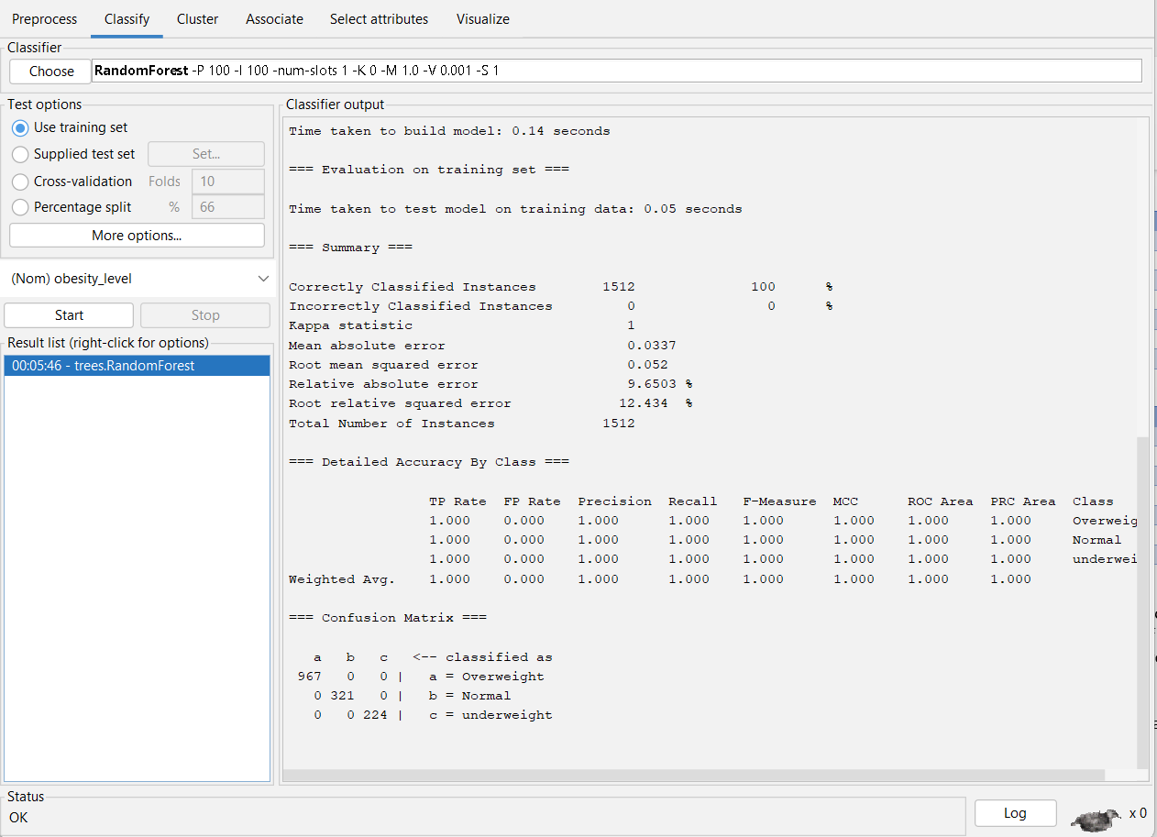

**Logistic regression for test data set:**

**Random tree :**

**Random forest:**

**Naïve bays:**

**FP growth:**

